COSC 3364 – Principles of Cybersecurity

Lab 06

Database Access Control and SQLi

Provide screenshots where \* is indicated.

Within MariaDB construct the following database named RECORDS:

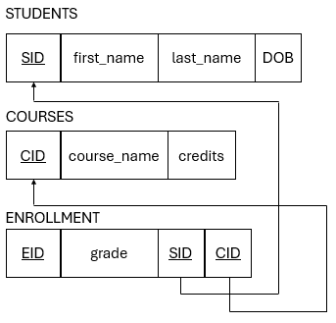

1. Create an admin user with all privileges and grant option.
2. Sign in as admin.
3. Create and use database RECORDS.
4. Generate the tables from the schema above and show tables.\*

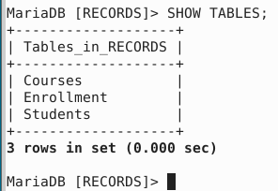

1. Insert three entries to each table and select all from each table.\*

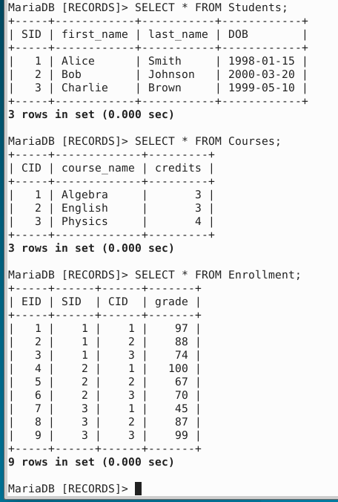

1. Create user Alice with all privileges and grant option.
2. Exit admin and sign in as Alice.
3. Create user Bob with SELECT privilege on RECORDS.ENROLLMENT.
4. Exit Alice, sign in as admin, and show all users.\*

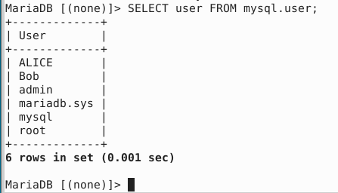

1. Revoke all privileges from Alice.
   1. What do you expect to happen to the SELECT privilege granted to Bob?

Bob will retain the privilege even though Alice’s privileges were revoked.

* 1. What did happen to the SELECT privilege granted to Bob?

Bob did retain the privilege (I also accidentally granted him all privileges instead of just SELECT privileges.)

1. Exit admin and sign in as Bob.
2. Generate SQL statement utilizing a where clause of unknown SID to display all grades.\*

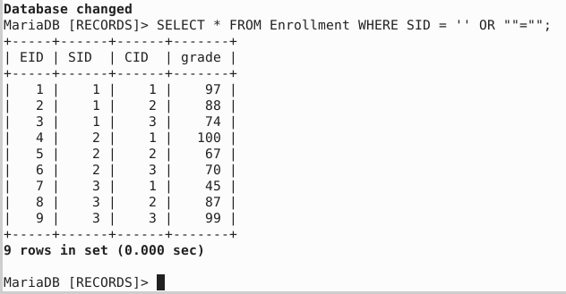

1. Attempt to include a drop table statement on ENROLLMENT along with previous SQL statement.\*

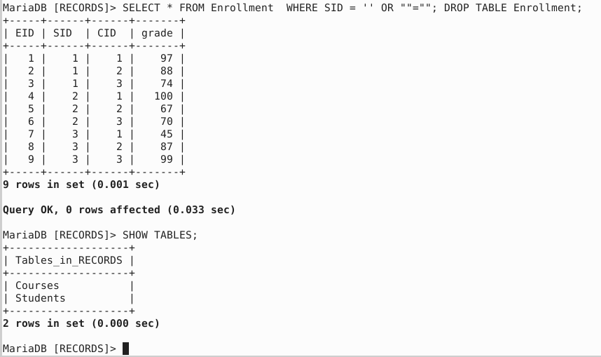

Mine did drop the table because I accidentally gave Bob all privileges.